**SURVEILLANCE SYSTEM AT NATIONAL BORDERS**

M SWATI

**SURVEILLANCE SYSTEM AT NATIONAL BORDERS**

**INTRODUCTION**

Advancements in technology and infrastructure are growing at a rapid rate making our lives easier. Increasing globalisation, urbanisation have accelerated the rate of population in the metropolitan cities during recent years.

A unique Passive Infrared sensor is used in the project which emits infrared rays to detect humans. As live human body emits thermal radiation it is received and manipulated by the PIR sensor to detect humans. Once the people are located it immediately gives audio alert visual alerts to the authorities so that help can reach the live person so fast. This PIR sensor is placed on a moving all direction robot that can manoeuvre in the national borders.

The robot is driven on a geared dc motor for increased torque and low speed and stepper motor for increased turning accuracy hence the precise control of position is monitored. The robot consists of a three wheel geared drive with DC motors attached to perform forward and reverse movement.

Borders are extremely vulnerable and prone to terrorist attacks, smuggling and illegal immigration

Border surveillance and protection requires a 24 / 7, day and night vision large area scanning system to detect, track and recognize unauthorized intruders- be they hostile forces, terrorists, smugglers or illegal immigrants or others. While in war time, or due to enemies attack in the borders. In such situations cause mass destruction and often lives get buried or some lives can be present in a war field in which the armed forces has a endanger to enter to save the lives of soldiers. Due to vast area that gets affected it becomes more difficult. Hence, we are proposing a human detection robot which can detect alive humans in field so that timely help can be made available to the victims.

The robot is equipped with a PIR sensor to detect live human, a robotic arm to remove any obstacles in its way, a camera to send images to control unit. Microcontroller SST89E516RD is used to control the robot and is the core of robot. The robot consists of a three wheel geared drive with DC motors attached to perform forward and reverse movements.

**PROBLEM STATEMENT:**

The question that arises in research an implementation of the project is as follows:

• How much efficient a robot can be made to detect live human in war fields and National borders.

• An autonomous robot must be capable of avoiding obstacle and take its own decisions regarding its further proceedings, when it encounters with an obstacle.

• For the National borders and War Fields it is unlikely to be a bright site or on other hand if performing operation in the night in addition to sensor how a robot can have a sight of view.

• How user friendly is the robot, GUI (graphical user interface) is too made easier to user, which hides irrelevant on screen information on the user side.

• How effective a communication system is to be established between a receiver and the transmitter side which communicates without any interference of the surrounding frequencies which may result in obstruction or complete annihilation of channel.

**PROPOSED SYSTEM:**

The project proposes an autonomous and manual controlled robotic vehicle that moves in the War fields, National Borders and helps in identifying the live people and rescue operations. Hence precious life can be saved by timely detection in the time during war even without the help of large number of rescue operators.

**BLOCK DIAGRAM: ROBOT END**

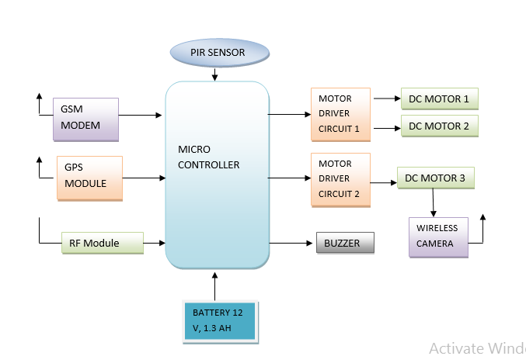

**CONTROL ROOM MODULE**

PC – HYPER TERMINAL

RF Module

**REQUIREMENTS:-**

**HARDWARE COMPONENTS:**

1. Embedded Microcontroller

2. Zigbee Transmitter and Receivers / RF Transceivers

3. PIR Sensor

4. DC Motor

5. Motor drive

6. Alarm

7. PC Interfacing

8. GPS Module

9. GSM Modem

10. Wireless Camera

**SOFTWARE REQUIREMENTS**

Embedded C

Arduino IDE

**WORK PLAN:**



**CONCLUSION**

Hence many lives can be saved by using this autonomous vehicle during a war in a short duration which becomes time-consuming and unaffected if done manually. The application of wireless sensor networks will improve the saving of many lives by using mobile rescue robots in war field areas. In this paper we design an effective & safe system to ensure that there is no human left behind in rescue operation.

**REFERENCES**

[1] Trupti B. Bhondve1, Prof.R.Satyanarayan2, Prof. Moresh Mukhedkar3, ‘Mobile Rescue Robot for Human Body Detection in Rescue Operation of Disaster’. International Journal of Advance Research in Electrical, Electronics and Instrumentation Engineering.

[2] Detecting Direction of Movement Using Pyroelectric Infrared Sensors by Jaeseok Yun, Member, IEEE, and Min-Hwan Song.

[3]. Human infrared signal recognition using single PIR detector-Linhong Wang Chongqing College of Electrical Engineering Chongqing, China.

[4] Miyama, S.; Imai, M.; Anzai, Y.; "Rescue robot under War Situation: position acquisition with Omni-directional Intelligent Robots and Systems, 2013.(IROS 2003), 27-31 Oct. 2013, vol.3, pp. 3132 - 3137.

[5].International Journal of Innovation Research and Development “Microcontroller Based Autonomous Robot System (MARS) for Rescuing Alive Human”.

[6]. Casper, J. “Human-Robot Interactions during the Robot-Assisted Urban Search and Rescue Response at the World Trade Centre”, IEEE, 2003, PP.367-385.

[7]. R. Fuksis, M. Greitans, E. Hermanis “Motion Analysis and Remote Control System using Pyro-electric Infrared Sensors” IEEE, 2008. No. 6(86), PP. 69-72.

[8]. Kun-Mu Chen, Yong Huang, Jianping Zhang and Adam Norman “Microwave Life-Detection Systems for Searching Human Subjects Under Earthquake Rubble or Behind Barrier” IEEE Transactions, Biomedical Engineering, VOL. 27, NO. 1, January 2000, PP. 105-114.

[9]. Miyama, S.; Imai, M.; Anzai, Y.; "Rescue robot under disaster Situation: position acquisition with Omni-directional Intelligent Robots and Systems, 2003.(IROS 2003), 27-31 Oct. 2003, vol.3, pp. 3132 - 3137.

[10]. Burion, Steve (2004), Casper, J. (2002), Amerada, Yams, Igarashit, &Matsunos, (2004) and Cappello, C., etal (2005) “Human Detection for Robotic Urban Search and Rescue” Carnegie Mellon University, Institute of Production Robotique (IPR) LSRO2 – VRAI-Group, Microtechnique, February 2014.